**Website Purpose and Theme:**

The purpose of this portfolio is to showcase my current skills, projects, and experience in the software development field. As an Integrations Specialist with 3 years of professional experience at Northwestern Polytechnic and a current 3rd-year BSc Computer Science student at Athabasca University, I aim to present my work to potential employers, freelance clients, and collaborators.

The site will evolve as I progress in my education and career, serving as both a static display of past achievements and a dynamic record of new learning. It will highlight programming skills, integration projects, technical blog posts, certifications, and professional goals.

The primary themes are professionalism, growth, clarity, and accessibility. The tone will be formal but friendly, the structure clean and navigable, and the layout responsive and accessible across various devices and browsers.

**Personas:**

1. Technical Recruiter (David)
   * Demographics
     + Name: David McMan
     + Age: 38
     + Photo:

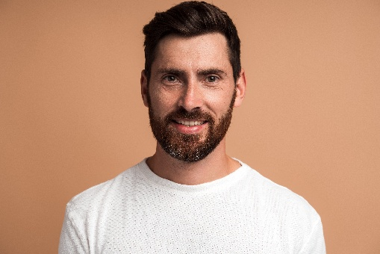

( Generated using <https://www.vecteezy.com/>)

* + - Job Title: Senior Technical Recruiter
    - Technical Skill Level: Moderate — understands roles and tech stacks
  + Motivations:
    - Quickly assess my background information and determine my fitness for client positions.
    - Identify my core technologies, work history, and availability
    - Save time by finding essential info fast
  + Frustrations:
    - No downloadable or easy-to-share resume
    - Unclear tech stack or missing job titles
    - No contact link
  + Goals:
    - David will land on my about page and will start by scanning for keywords like frameworks, roles and certificates to assess if I am a fit for the jobs he is recruiting for.
    - Should I meet his expectations, he will then go over to my resume section where he will print the resume and send it to the hiring manager.
    - David will then visit the Contact me page to schedule an interview once the hiring manager approves.

1. **Software Development Team Lead (Angela)**

* **Demographics**
  + - **Name:** Angela Patel
    - **Age:** 35
    - **Photo:**



(Generated using <https://www.vecteezy.com/>)

* + - **Job Title:** Software Development Team Lead
    - **Technical Skill Level:** Advanced
* **Motivations:**
  + - Assess whether I follow modern development practices and industry standards
    - Review real-world examples of my code and see if I would be a good fit for her team
    - Find out if I’m a proactive, thoughtful developer who documents and reflects on my work
* **Frustrations:**
  + - Vague or shallow project descriptions without technical depth
    - Poorly structured UI/UX
    - Projects that look impressive visually but lack meaningful content or code
  + **Goals:**
    - Amira will first explore my **Projects** section to evaluate the complexity and quality of the work
    - She will dig into project write-ups and view GitHub links to inspect code and documentation
    - She will then review my **About Me** page to determine whether my background and personality align with her team’s values and environment
    - If everything checks out, she might bookmark the site for future collaboration or reach out for a technical interview

1. **Computer Science Student (Carlos)**

* **Demographics**
* **Name:** Carlos Mendes
* **Age:** 25
* **Photo:**

  
(Generated using <https://www.vecteezy.com/>)

* **Job Title:** Computer Science Undergraduate Student
* **Technical Skill Level:** Intermediate
* **Motivations:**
* Learn from the structure and presentation of my personal portfolio
* Discover how to explain and reflect on coding projects
* Get inspired by the types of tools and languages I’ve worked with
* **Frustrations:**
* Jargon-heavy technical writing with no explanations
* Lack of source code or context
* Sites that are not responsive or mobile-friendly
* **Goals:**
* Carlos will start by browsing the **Projects** section to read summaries and view code examples
* He’ll move on to the **Blog/Reflection** section where I share learning insights and challenges
* If interested, he’ll bookmark the site or return later when building his own portfolio

1. **Small Business Owner (Lori)**

* **Demographics**
* **Name:** Lori McAllister
* **Age:** 29
* **Photo:**



(Generated using <https://www.vecteezy.com/>)

* **Job Title:** Small Business Owner
* **Technical Skill Level:** Low
* **Motivations:**
* Find a capable and professional freelance developer for her business website
* Understand my services and see proof of work
* Feel confident that I can communicate clearly and deliver quality products on time
* **Frustrations:**
* Overly technical language or cluttered layout
* Lack of clear pricing, offerings, or way to reach out
* **Goals:**
* Lori will begin at the **Home** or **About Me** page to get a sense of who I am
* She’ll look for clear, easy-to-understand examples of previous work in the **Projects** section
* If she’s impressed, she’ll visit the **Contact Me** page to ask for a quote or discuss a possible project
* A testimonial section or client success stories will help build her confidence in hiring me

**Scenarios:**

1. David (Recruiter) Quick Candidate Evaluation

David McMan, a seasoned technical recruiter, is scanning through LinkedIn profiles looking for a developer with integration experience and exposure to cloud platforms when he comes across my name. Curious, he clicks through to my portfolio site. He’s on a tight schedule and wants to quickly assess whether I’m a potential fit for a role involving API integrations and cloud services.  
He lands on my **About Me** page, scanning for skills and keywords like “Azure,” “REST APIs,” and “integrations.” Satisfied with the skills, he clicks over to the **Resume** section and schemes over my previous employment history. Before wrapping up, he opens the **Contact Me** page to send a message requesting availability for a screening interview.

1. David (Recruiter) Needs a Printable Resume Now

It’s 9:45 AM, and David has a candidate meeting with a hiring manager in 15 minutes. One of the names he’s considering is mine. He quickly pulls up my portfolio site and navigates to the Resume section. He’s relieved to find a neatly formatted, downloadable PDF of my resume, which he prints immediately to add to the candidate briefing folder.

1. Angela (Dev Team Lead) Reviewing Code Quality

Amira, a team lead at a fast-paced software company, is vetting candidates for a new integration-focused role. She already has my name from a recruiter but wants to evaluate how I think and code before recommending me for an interview.

She browses the Projects section of my site, opening links to my GitHub repositories. She’s impressed by the clear README files, sensible project structure, and concise write-ups about what I built and why. She bookmarks my site to return later with her junior developer for a second opinion.

1. Angela (Dev Team Lead) Evaluating Team Fit

Later that week, Amira returns to my site not to look at code, but to see if I’d integrate well with her collaborative team. She reads through my About Me section and then opens my Blog, where I write about challenges I’ve faced, what I’ve learned from previous roles, and how I collaborate with designers and testers. The personal tone and thoughtful writing reassure her that I’d likely fit well with her team’s culture.

1. Lori (Business Owner) Looking for a Freelancer

Lori, who runs a small shoe business, needs someone to revamp her outdated website. A colleague recommends my name. Lori visits my portfolio and is pleased to see clean design, easy navigation, and relevant projects. She reads through the about me page to understand who she is dealing with.

She then goes over to the Project section where she focuses on a project where I built a simple e-commerce site, reading how I approached client communication and mobile optimization. Convinced of my reliability, she heads to the Contact Me page to request a quote.

1. Carlos (CS Student) Looking for Portfolio Inspiration

Carlos, a second-year computer science student, is browsing for portfolio ideas as part of a class project. He stumbles on my site through a student dev blog and spends time exploring every section.

He’s particularly interested in how I’ve structured my about me page. The tech stack icons, short summaries, and embedded GitHub activity gives him a solid idea of how to build his own. Inspired, he bookmarks the site and shares it with his peers.

**Further requirements:**

As I develop my personal portfolio, I will make deliberate choices to ensure it meets important ethical, technical, and institutional standards. I will consider color contrast, text alternatives, and keyboard navigation to ensure the site is usable for all visitors. I also want the site to authentically represent who I am as a developer and lifelong learner, while maintaining a professional tone that reflects my values and goals. Since I am currently employed at Northwestern Polytechnic, I will work with my manager and HR to ensure my site remains compliant with institutional policies and does not result in any conflict of interest. On the technical side, I will design the site to be mobile-responsive, so it works seamlessly across devices. And because the course restricts server-side processing, I will focus on static technologies like HTML, CSS, and JavaScript, without relying on databases or user authentication.

**Site Map / Mock-ups**

My website is structured to provide a clear, professional, and engaging experience for various visitors, including recruiters, collaborators, and potential clients. The main entry point is the About Me page, which also acts as the homepage. From there, visitors can navigate to dedicated sections that serve specific purposes.

**About Me**

This is the landing page that gives a strong first impression. It includes:

* A contact card with essential links (LinkedIn, GitHub, email)
* A brief biography and professional background
* A list of technical skills and competencies
* Highlights of recent or featured projects
* (Optional) GitHub activity feed to show ongoing engagement in coding

**Projects**

This section showcases my personal and professional projects. It includes:

* A project filter (by technology or category)
* A project list/grid with screenshots, descriptions, and links to code or live demos

**Resume**

This section is structured for quick assessment by recruiters and includes:

* Education history
* Certifications and achievements
* Work experience and roles held
* A button to download the full resume as a PDF

**Contact Me**

Allows anyone to reach out directly through:

* A simple and accessible contact form
* Alternative contact methods (email, LinkedIn, etc.)

**Blog**

Also referred to as my **Reflection Dairy**, this section contains:

* A list of blog entries reflecting my learning progress through each unit of the COMP266 course
* Additional thoughts, technical breakdowns, or helpful resources.

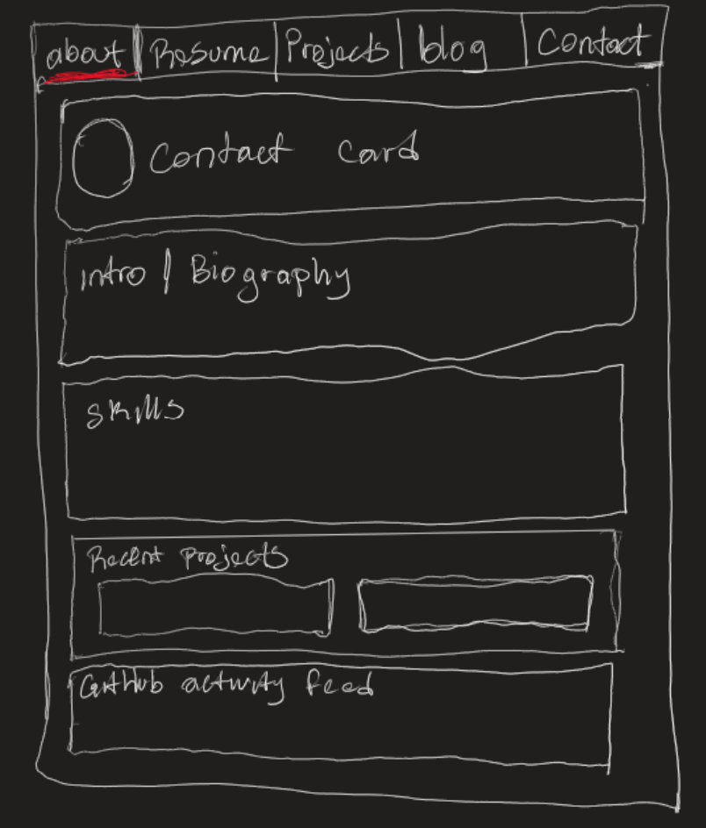 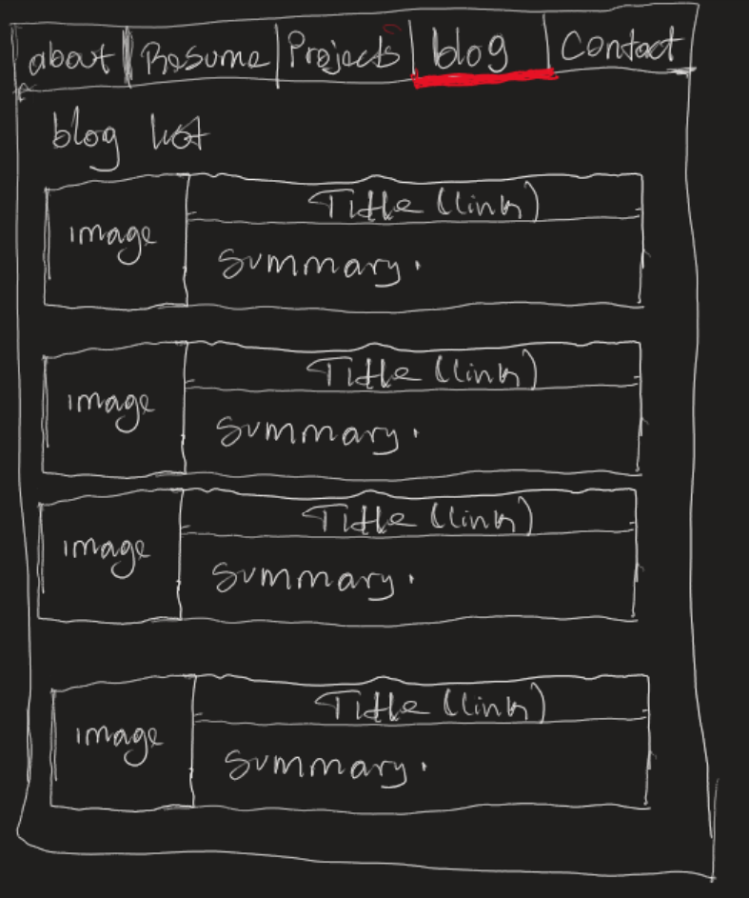

**Unit 1 Reflection**

As part of the work for Unit 1, I focused on laying a strong foundation for my personal portfolio website. I began by defining the purpose of the site; to showcase my skills, experience, and personal growth as a software developer. I then created three distinct personas: a technical recruiter, a fellow developer looking for collaboration, and a peer student. These personas helped me think critically about the range of users who might visit my site. I also wrote detailed user scenarios to imagine how each of these personas would interact with the website in a real-world context. Using these insights, I developed a structured and user-focused site map, with clear sections such as “About Me,” “Projects,” “Resume,” “Contact Me,” and “Blog.” This sitemap reflects the key user goals identified in the personas and scenarios and is designed to support smooth navigation and quick access to relevant information.

The rationale behind my design choices is deeply rooted in the personas and scenarios I developed. For David, the technical recruiter, the priority is efficiency. He needs quick access to my key skills, certifications, and a downloadable resume. This directly influenced my decision to consolidate relevant details on the About Me page and include a clear, printer-friendly Resume section. Angela, the software team lead, is more technically advanced and interested in the depth of my projects and adherence to modern development standards. To support her goals, I designed the Projects section to include code summaries, GitHub links, and documentation for each project. Carlos, the computer science student, is looking to learn and be inspired, so I planned a Blog section where I’ll reflect on my development journey and explain decisions in simple, accessible terms. Lastly, Lori, the small business owner, has limited technical background but wants to feel confident in my reliability. For her, I kept the design clean, jargon-free and ensured the Contact Me page was simple to navigate. These user needs guided every major content and layout decision I made in this unit.

The research process for Unit 1 has significantly influenced how I view user-centered design. I learned from [Interaction Design Foundation’s blog on personas](https://www.interaction-design.org/literature/topics/personas) that personas are not just fictional placeholders, but research-based representations that help in designing more empathetic and effective user experiences. This shifted my thinking—from typically grouping users by roles to instead focusing on specific, individual behaviors and goals. Another valuable source was their [user scenarios article](https://www.interaction-design.org/literature/topics/user-scenarios), which clarified the difference between broad use cases and narrow, story-based scenarios. This helped me create realistic, goal-driven narratives for each persona.

To ensure these personas and scenarios reflected real-world contexts, I browsed various Quora threads and articles about personal portfolios, learning what users expect when they visit such sites. I also used resources like [Justinmind’s guide on scenarios](https://www.justinmind.com/blog/how-to-design-user-scenarios/) to write well-structured, meaningful stories. Initially, I found it challenging to switch my thinking from jumping into site maps and wireframes to first investing time into personas and scenarios. However, once those foundational elements were in place, the sitemap and layout came together smoothly. It’s a lesson I’ll carry forward into future projects.

One major challenge was resisting the urge to start coding immediately. I had to constantly remind myself to stay focused on the design and planning process. But now that the design stage is complete, I feel well-prepared and excited to begin the actual development. This early work has not only clarified my project’s direction but also improved my overall approach to web development.